Design, Implement, Secure and Troubleshoot the Next-Generation Network Infrastructure for Bells University, Ota, Ogun State, Nigeria (2025–2030 Roadmap)

BY

ABAGUN OKIKIOLA OLUWAFUNMILAYO
2021/10165

A PROJECT SUBMITTED TO
ICT
BELLS UNIVERSITY OF TECHNOLOGY, OTA, OGUN STATE, NIGERIA.

JULY 2026.

CHAPTER ONE
INTRODUCTION
1.1 Background of the Study

Modern schools, colleges and universities are overly relying on the strong and carefully organized computer networks to support the academic, administrative, and security processes. The more users and networked devices are, the more is the growing demand of a network infrastructures, which are scalable, secure and reliable. Poorly implemented networks can lead to congestion, security breaches and system blackouts.
To overcome these issues, principles of network design that are among the industry standards like Cisco hierarchical model of networking is commonly embraced. The model separates the network into functional layers, which allows it to perform better, easier to administer, and does not complicate the troubleshooting complex.

1.2 Aim and Objectives of the Project.
The main aim of this undertaking is to develop and deploy a campus network that meets the requirements of the CCNA standards and best practices by utilization of Cisco packet Tracer.

The objectives of the project are in particular to:
- Develop a hierarchical campus network using 3 level hierarchical model.
- Introduce sound network segmentation Virtual local area network (VLAN).
- - Allow effective multi-network segments intercommunication through inter-VLAN routing.
- Aggregate link and gateway redundancy, thereby offering redundancy and high availability.
- make the network design scalable, manageable and secure.

1.3 Scope of the Project
The infrastructure of this project is focused on the network infrastructure on an inner campus. It involves planning and architecture of the core, distribution and access layer devices such as switches, and routers. VLAN configuration, trunking, inter VLAN routing preparation of redundancy mechanism, which include Ether Channel and HSRP, are also part of the project.
More complex enterprise functionality like full firewall implementation and intrusion detection are out of the boundaries of this study though can be extended into further developments.

1.4 Significance of the Project
This network implementation is the evidence of the effectiveness of the applied ideas of CCNA networking, hierarchical design, VLAN segmentation, and Layer 2 and Layer 3 switching. The project provides a true simulation of campus network environment and forms the base of more sophisticated network research and applications.
In addition, the network architecture will facilitate effective use of resources, provide greater security due to logical segregation, and high-availability, essential conditions of modern campus environments.

1.5 Methodology
The approach that will be used in this project is systematic as it involves network planning, logical and physical design, configuration, verification and documentation. The simulation platform used is Cisco Packet Tracer that is used to simulate topology and carry out configurations.
The verification is conducted with the help of standard Cisco IOS commands which should check a correct VLAN propagation, trunking, and stability of the network. All the settings and findings are carefully recorded to facilitate assessment and future encounter.

CHAPTER TWO
Network architecture and design.

The following is an overview of the Network Architecture.
Campus network was planned to be developed based on Cisco hierarchical network architecture which logs the network into different functional levels. It is a protocol of simplifying the architectural process, elevating the performance of operations, and facilitating scaled-up structure by assigning duties to different layers.
The hierarchical model adopted to undertake this venture will consist of three major layers; the Core layer, Distribution layer as well as the Access layer. Every stratum has specialized functions in which they make sure effective data transmission and fault tolerance and easily administered administration.

2.2 Hierarchical Network Model
2.2.1 Core Layer
The core layer also acts as the central section of the campus network, which has the responsibility of high rate data transmission through the differences in network sections. Two Layer 3 switch was placed in the core in this project to provide quick and efficient routing.
The central layer has been designed in order to enable inter-VLAN routing as well as future gateway redundancy. The use of several core switches guarantees a highly available network and is ready to implement the use of a fail over mechanism like Hot Standby Router Protocol (HSRP).

2.2.2 Distribution Layer
Distribution layer is a layer that acts as a relay between access layer and core layer. It consolidates traffic source of the access switches and imposes network policies, such as VLAN propagation and trunking.
A special distribution switch is used in this deployment between the access layer and the core layer. The configuration of trunk links was based on IEEE 802.1Q that enabled support of many VLANs passing through the network and being efficient. The distribution layer, also, provides a stable Layer 2 topology by the use of the Spanning Tree Protocol (STP).

2.2.3 Access Layer
The access layer provides direct connection to the end-user devices (p.g. computers, printers and security systems). Several access switches were placed in the different buildings and divisions in the campus.
Access switches were set to assign the end devices to the different VLANs. The trunk uplinks linked access switches to access the distribution layer to enable forwarding of VLAN traffic with an appropriate use of network segmentation.
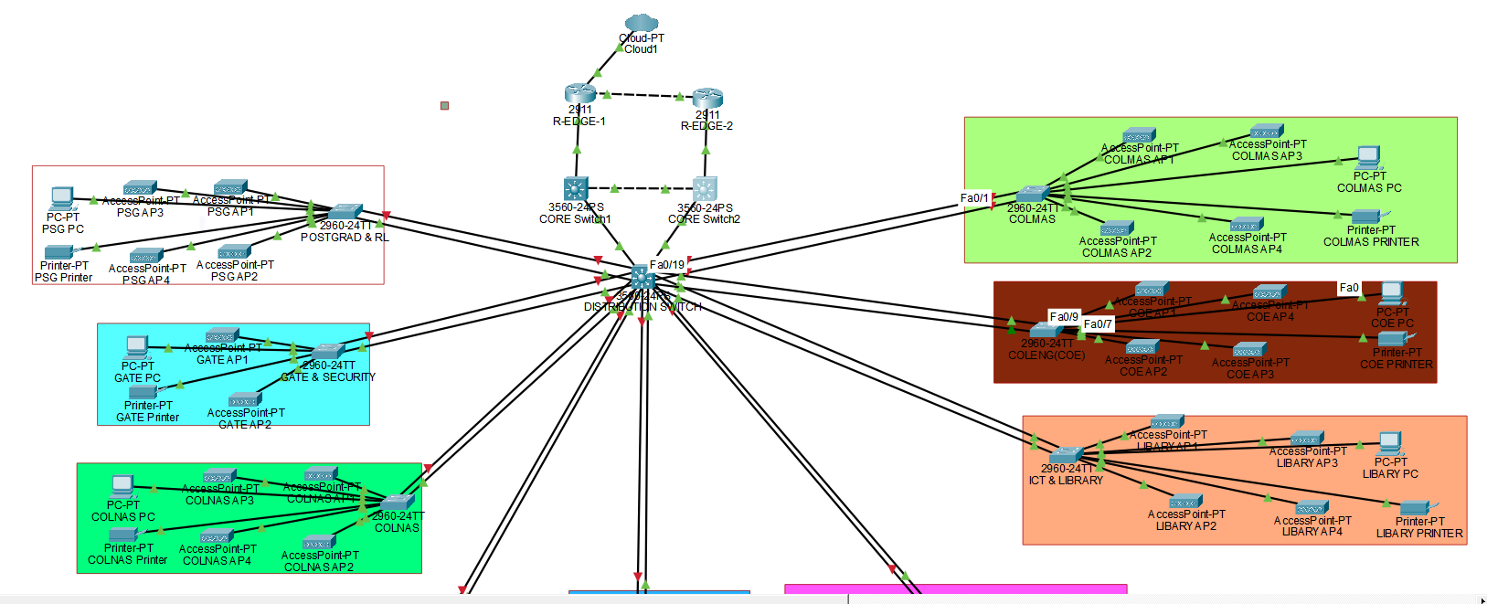

2.3 Physical Network Design
Physical network design engages routers, switches and devices at the end of the network bridged through Ethernet cables. The connection to the outer networks is realized based on edge routers, being connected to an ISP cloud.
At the access and distribution levels, fast Ethernet interfaces were mostly used, with more capacity interfaces being used on the core and edge levels. To improve reliability and make the network ready to aggregate the links, physical links redundancy was made between the access and distribution layers.
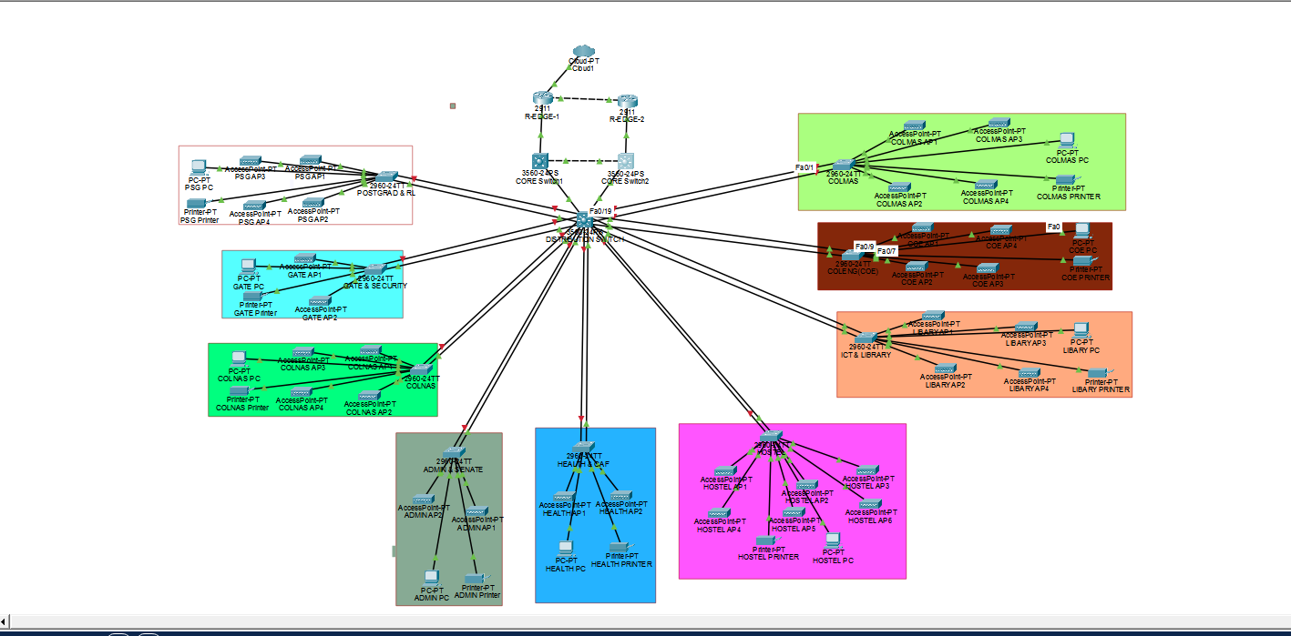

2.4 Logical Network Design
The logical design is based on the VLAN and IP subnetting. VLANs had been developed to organize users based on their functional role, hence enabling an easy control of traffic and high security.
Logical separation minimizes the broadcast domains and yet maintains the ability to direct traffic across VLANs in any instance. Switch Virtual Interfaces (SVIs) were used to achieve inter-VALAN routing at the core layer.
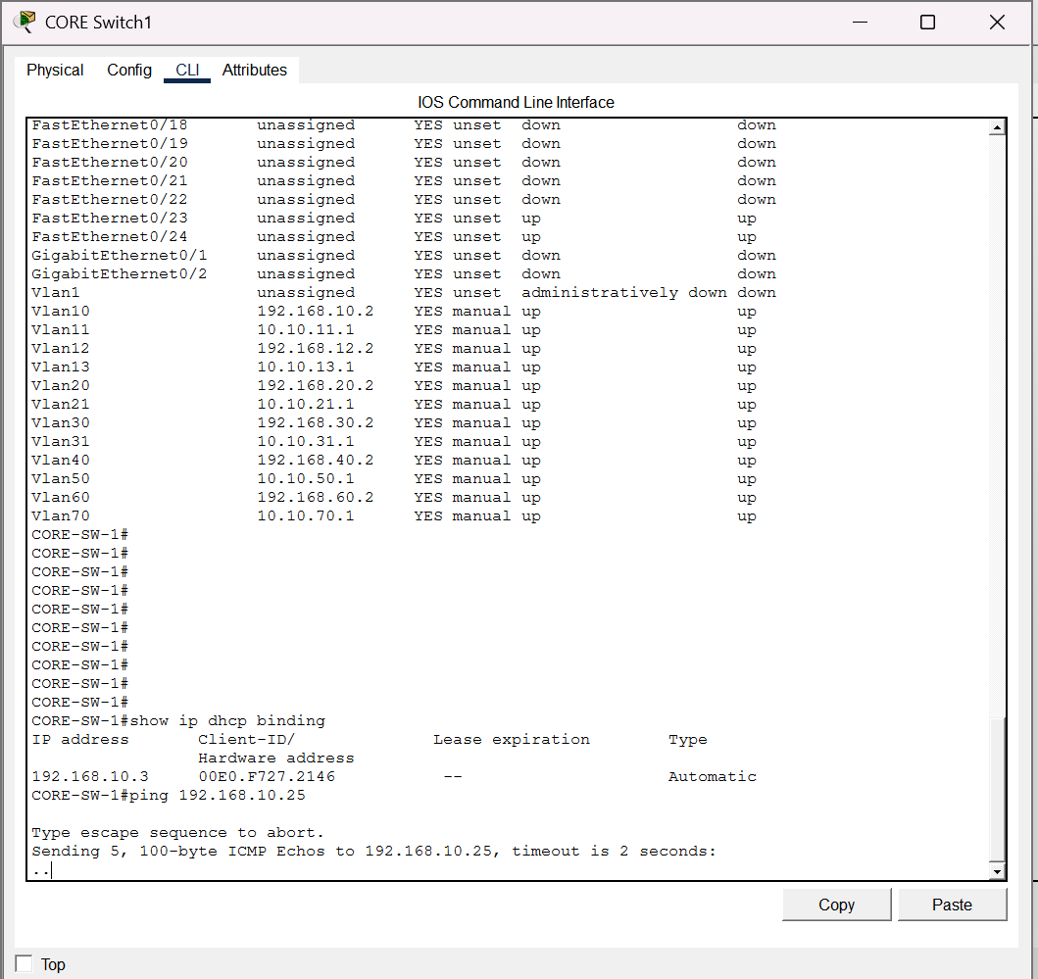

2.5 Design of Research Structure and Methodology.
Several considerations during the network design stage entailed scalability, performance, redundancy as well as manageability. The hierarchical model also allows the network to grow and not require a massive redesign, and the VLAN segmentation also improves the performance and security at the same time.
Redundancy of the links and the intended use of EtherChannel and HSRP, is used to ensure that there is high availability and fault tolerance. The general architecture is in line with best practices of the CCNA and compliments with traditional implementations of networks in campuses.

CHAPTER THREE
VLAN DESIGN AND LOGICAL SEGMENTATION
3.1 Introduction to VLAN Design
A pressing need to control traffic and provide high levels of security pervades modern campus networking setups in step with the growth in network size and complexity. Virtual Local Area Networks (VLANs) represent a logical method of subdivision of physical network into specific broadcast domains and thus avoiding unnecessary broadcasts and enhancing security by compartmentalization of separate groups of users.
In the current research, VLANs were used as the major means of logical segmentation, which ensures that users and devices carrying out similar tasks are merged despite being in their different physical locations.

3.2 VLAN Planning and Grouping Strategy
The architectural design to integrate VLAN was based on functional roles that are intrinsically based on the academic milieu. The end-users were categorized based on their academic, administrative, and operational duties, a strategy that simplifies the implementation of the policies and enhances the network controls.
Student groups were concentrated into several VLANs so that the network load could be evenly distributed and prospective scalability was enabled. The faculty staff was dichotomized and divided into academic and non-academic classes, with further differentiation between administrative and non-administrative positions. Further VLANs were created to manage network infrastructure, printer services, server clusters as well as security equipment.

3.3 VLAN Allocation Scheme
The allocation scheme used on VLAN allocation varies in the network and it is presented in the following table:
VLAN ID | VLAN Name | Description
10 | STUDENTS_A | Student group A
11 | STUDENTS_B | Student group B
12 | STUDENTS_C | Student group C
13 | STUDENTS_D | Student group D
20 | ACADEMIC_STAFF | Academic staff.
21 | ACADEMIC_ADMIN | Academic administrators
30. | NON-ACADEMIC STAFF | Non-academic staff
31 | NONE_ACADEMIC_ADMIN. | None_Academic_Admin.
40. | NETWORK_MANAGEment | Network management
50 | PRINTERS | Printer services
60 | SERVERS | Server network
70 | SECURITY | Security systems

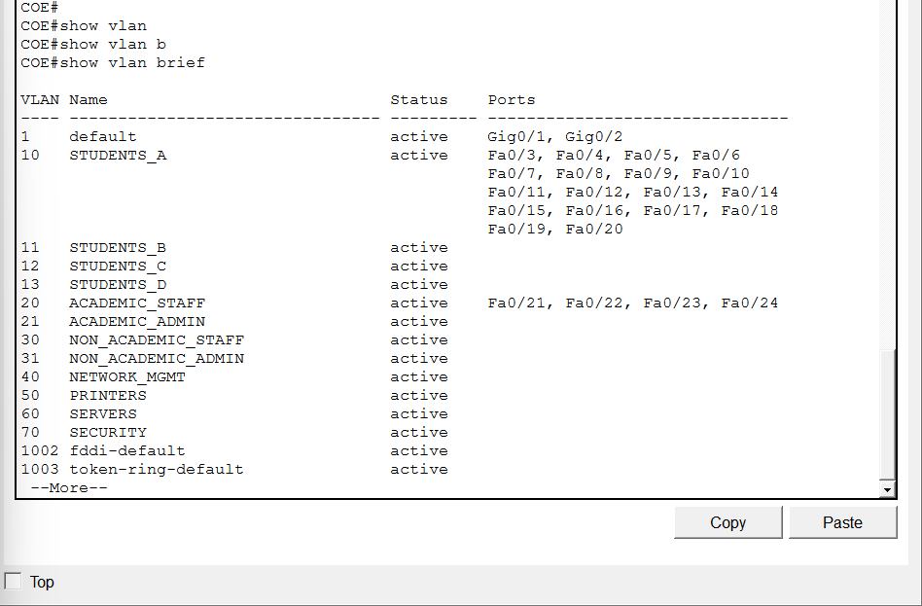
3.4 VLAN Implementation
VLANs were configured in core, distribution and access layers in order to ensure consistency throughout the network topology. IEEE 802.1Q trunking was introduced on inter-switch connections, and allowed multiplexing of VLAN traffic across single physical connections.
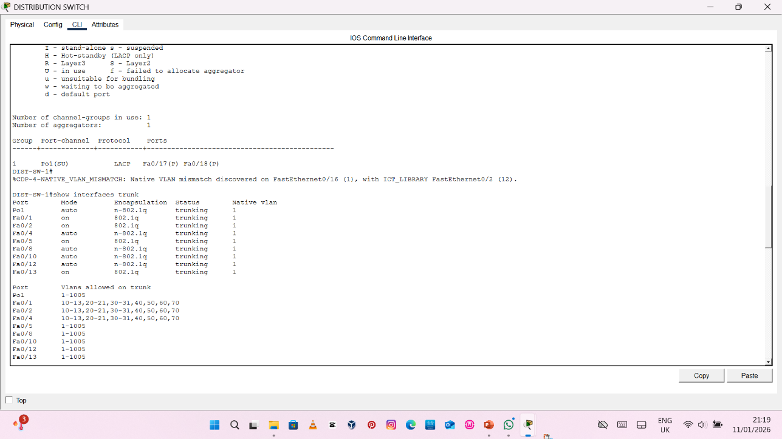

The distribution switches were configured with access ports as the static access ports which were bound to the corresponding VLANs hence making sure that upon connection, endpoints were automatedly enrolled to the suitable logical domain.

3.5 VLAN Segmentation Advantages.
There are a number of salient benefits associated with the application of VLANs in this case:
- Minimalization of broadcast traffic by demarcation of domains.
- Strengthening of security through logical departmental isolation.
- Enhancement of operations and network performance.
- Streamlining of troubleshooting and management control.
- Support of scalability in network resources.
With the introduction of VLAN-based segmentation, the network will be introduced to the optimal balance between flexibility, performance, and security, which would be in line with the modern best practices of CCNA level design network architecture.

CHAPTER FOUR
CORE IMPLEMENTATION and DISTRIBUTION LAYER IMPLEMENTATION.

4.1 Introduction
The central and network layers are the main elements of the infrastructure of the campus network. Their main roles include effective data forwarding, strict implementing policies as well as maintaining the targets within the entire network. In this context, the core and distribution layers of this project have been carefully designed to support VLAN based segmentation, inter VLAN routing and scalable aggregation of traffic.
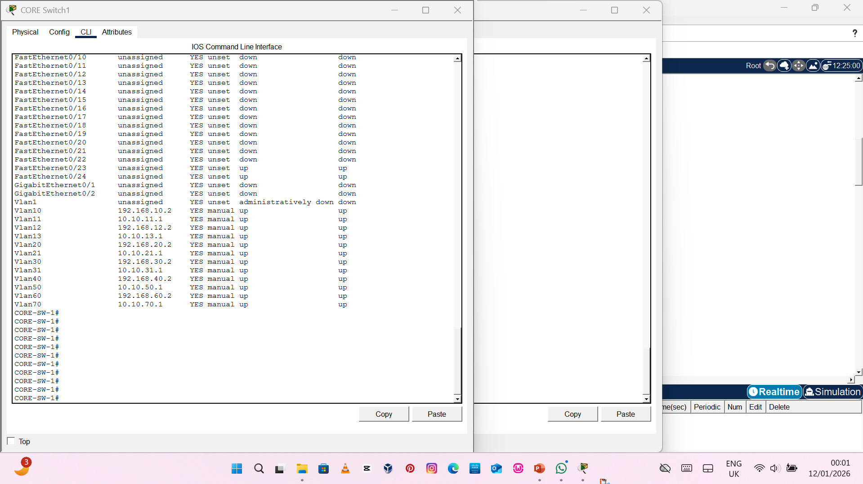

4.2 Core Layer Implementation
The core layer was achieved by installation of 2 switches of Layer 3 that are capable of providing high speeds in routing and also high standards of redundancy. The switches are the main base of the network and coordinate the traffic routing of different VLANs.
The core layer had inter-vlans routing that was enabled through Switch Virtual Interfaces (SVIs). A separate SVI was allocated to each VLAN to serve as a default gateway to all the devices in that VLAN, thus allowing traffic between groups of devices to access the desired equipment without loss of logical separation.
The dual-core topology was deliberate to support redundancy methods including Hot Standby Router Protocol (HSRP) ensuring that no gaps are experienced in network connectivity in case of a device or linkage breakdown.
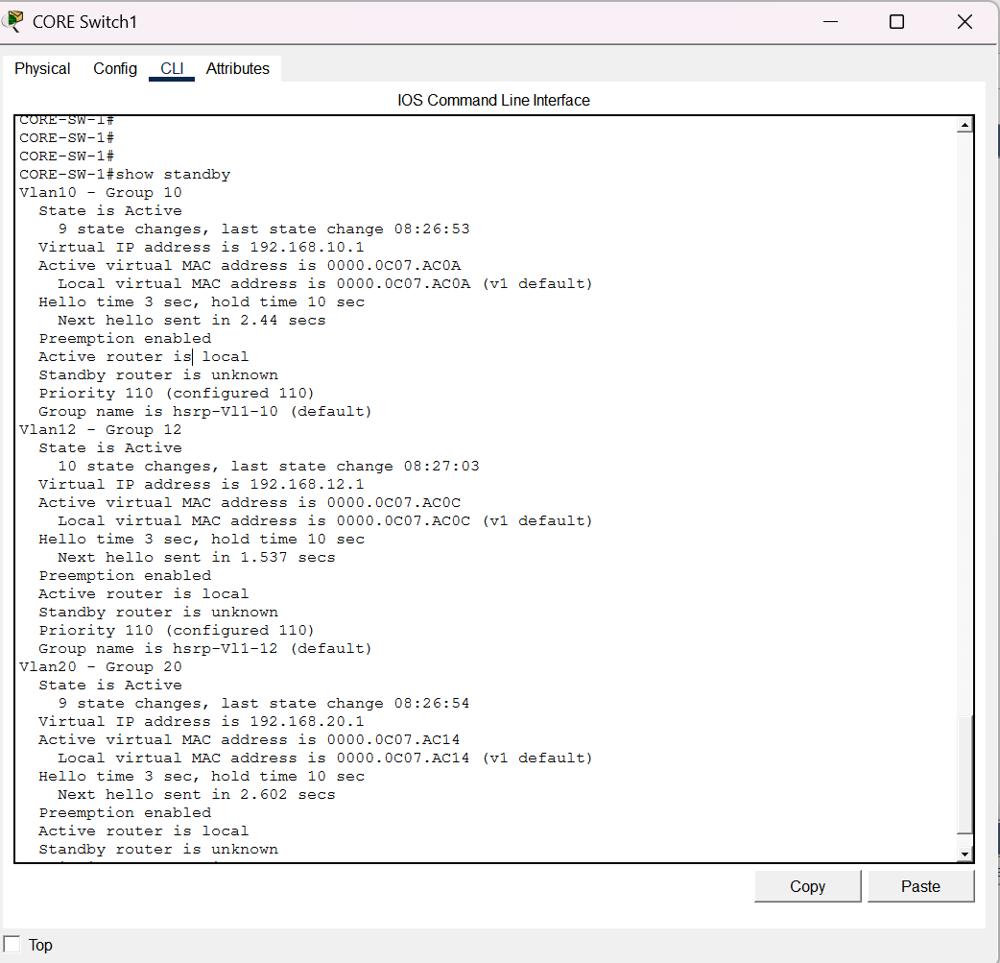

4.3 Implementation of the distribution layer.
A special Layer 2 switch was placed between the core and access layers which acted as the distribution layer. It is used primarily to consolidate the traffic of the access switches and send it effectively to the core layer.
The connection between the distribution switch and the core switches using IEEE802.1Q encapsulation was trunked. These trunks will allow various VLANs to pass across a single physical link without losing VLAN tagging, which will enhance uniform segmentation across the network.
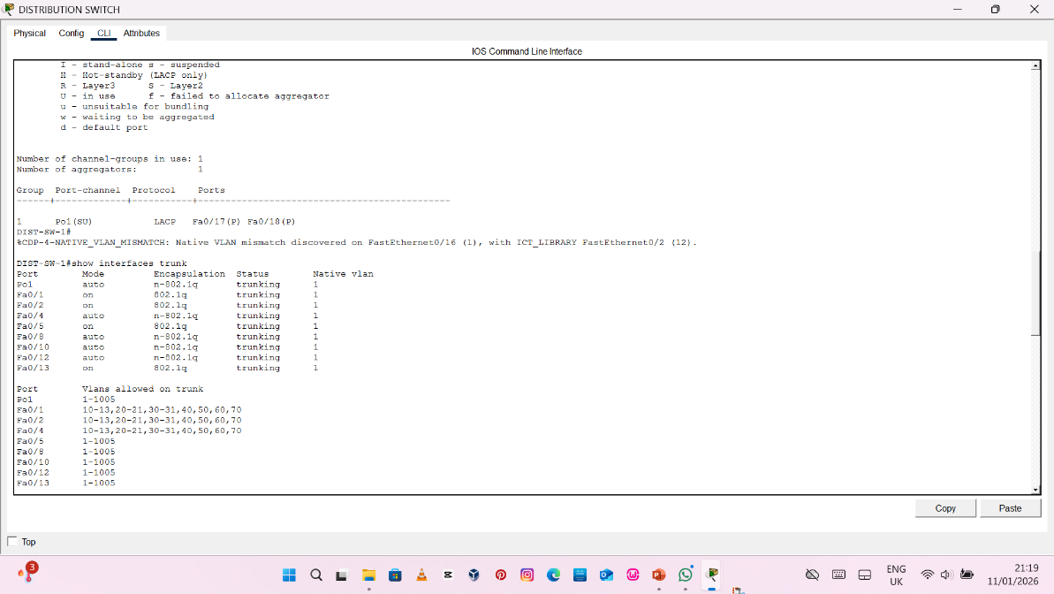

4.4 Trunking and Spanning Tree Protocol.
The Spanning Tree Protocol (STP) was implemented on the network to maintain a loop free Layer 2 topology. STP is dynamic in identifying path redundancies and blocking paths before ensuring that there is at least one active path to pass the data.
First, redundant uplinks between the distribution and access layers were intentionally limited to prevent the occurrence of loops hence improving network stability and gearing the infrastructure to the eventual enablement of the introduction of EtherChannel, which will bundle redundant connections into one logical connection.
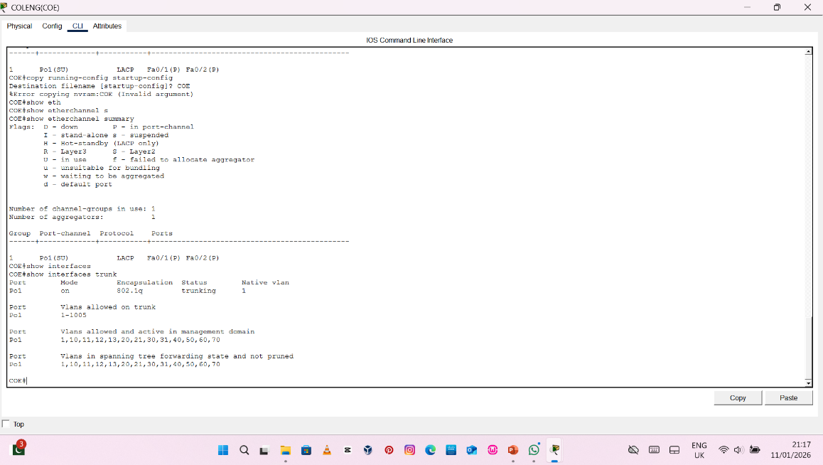

4.5 Verification and Stability
The core and distribution layer settings were verified using the basic Cisco IOS commands. These commands confirmed the existence of VLAN, status of trunk and routing capability.
This process of verification confirmed:
VLANs were available constancy amid core switches as well as distribution switches.
* Trunks links were working and were able to carry VLAN traffic.
* The topology of the Layer 2 was stable and loopless.
The findings are a support of the fact that the core and distribution layers have been implemented appropriately and they have the ability to fully support end-to-end network connectivity.
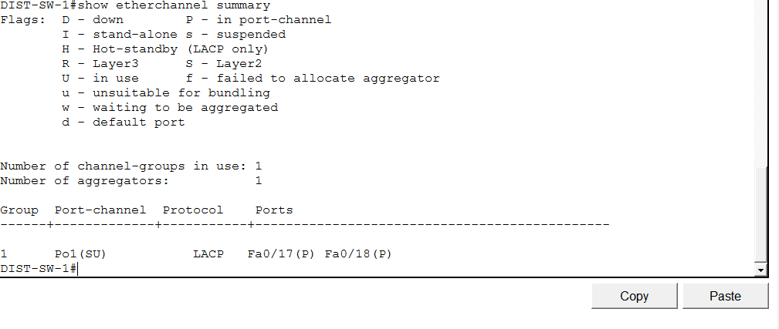

CHAPTER FIVE

5.1 Introduction
Access layer the point where the end-user devices connect to end-user devices such as computers, printers, and security systems.

5.2 Access Layer Design
The access layer consists of 9 access switches with strategic locations distributed to provide services to different user groups and campus locations. The access switches are connected to end-user devices such as computers, staff works, printers, and security tools of students.
It is a design that focuses on consistency, developing around simplicity and scaling. A uniformity was also enforced in the standardised configurations of all the access switches to ensure uniform behaviour and ease management.
The access switches had unique hostnames and the necessary VLANs assigned to them, to ensure coherence within the network. Their user roles and the needs of different departments were used to assign them access ports, which were assigned to the VLANs at a static location.
The IEEE 802.1Q was used to create trunk uplinks between the distribution switch and the access switches. First, only one uplink of access switch has been enabled to avoid Layer2 loops and the second uplink is administratively disabled awaiting the addition of link aggregation.
NOTE:
Only Access switch (coleng COE) is full configured and tested, others follow same configuration

5.4 Redundancy Preparation and Redundancy Link Aggregation.
In order to increase the network reliability and availability, the access layer to distribution layer was redundantly physical linked. All these were ready links that could be configured using the Etherchannel in the Link Aggregation Control Protocol (LACP).
This allows the network to use multiple physical links combined into one logical PortChannel providing a higher bandwidth and automatic back up in case of a physical link failure. This architecture also ensures end-user devices connectivity at all times.
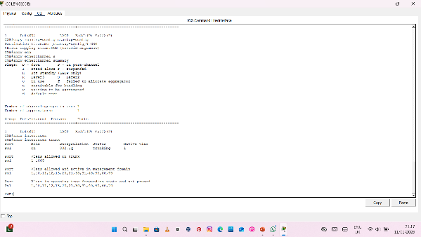

5.6 authentication to Access Layer Connectivity.
Configuration check of the access layer was achieved by using Cisco IOS commands to verify that VLAN was assigned properly, trunk was operational and link was properly healthy. Verification process In the process of verification, the procedure showed that VLANs had the appropriate access ports and that the trunk links were working.
The successful testing establishes that the network can provide the reliable and scalable network connectivity to all end users on the campus.
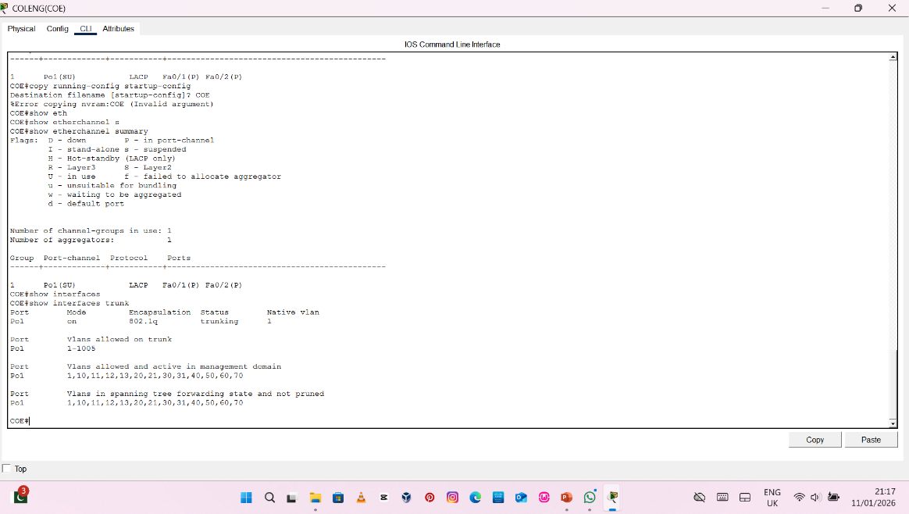
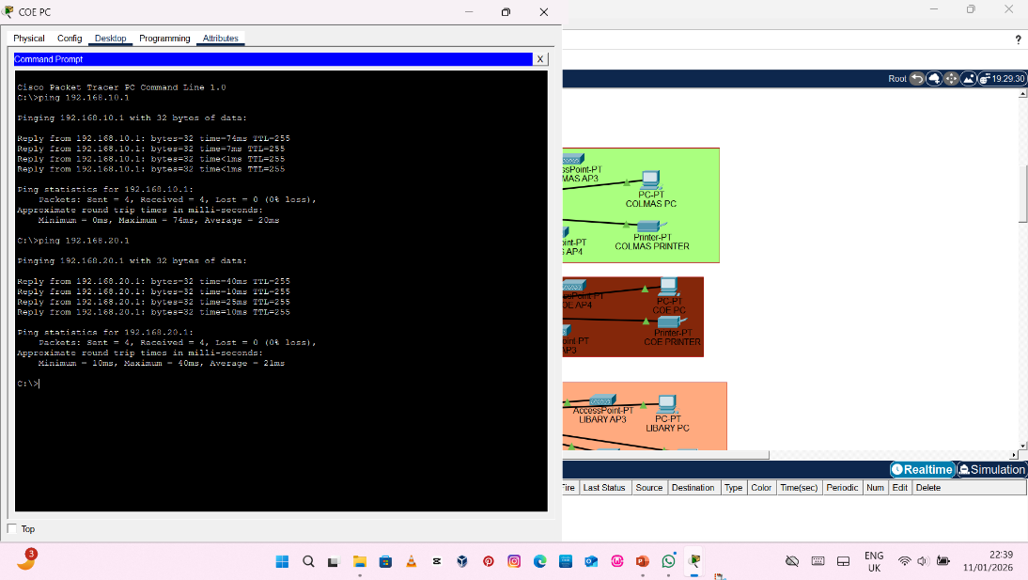
END DEVICE CONNECTIVITY (PC PING TEST)
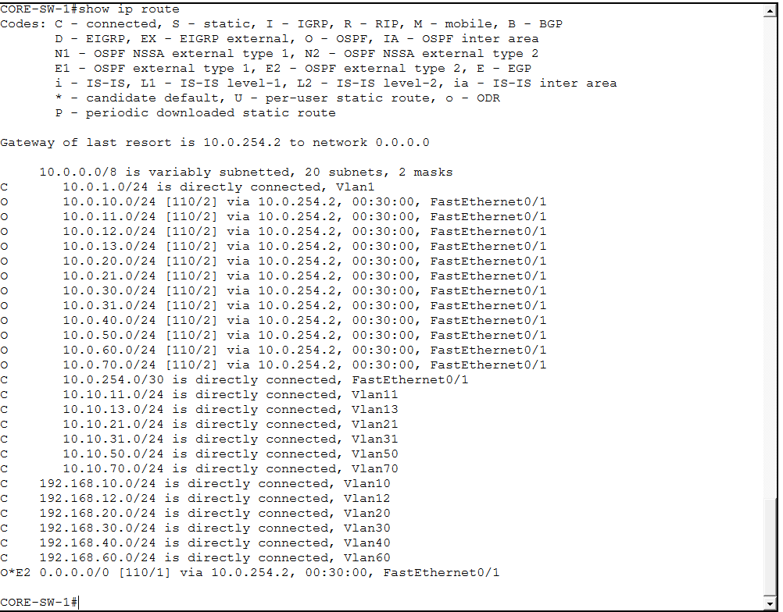
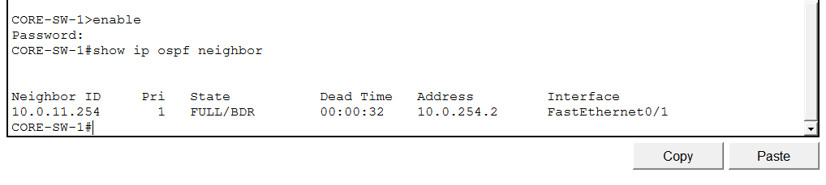
TESTING AND RESULTS
All functional testing and verification were conducted using the fully configured access switch, which serves as a reference implementation for the remaining access switches in the campus network design.
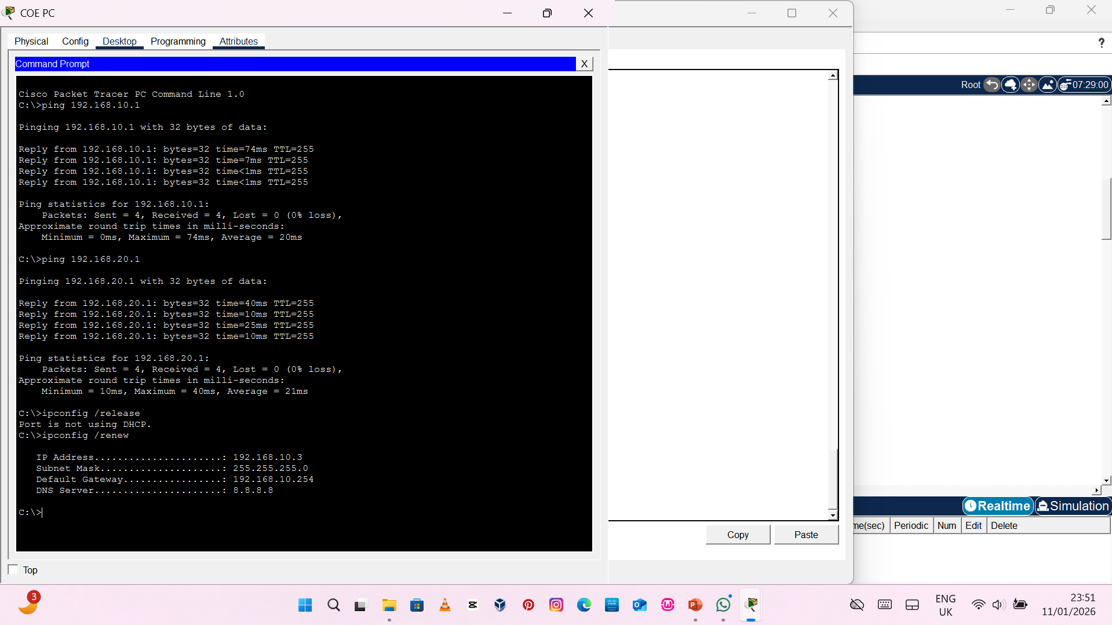
Conclusion
This project successfully designed and implemented a hierarchical campus network for Bells University, Ota. The network achieved effective VLAN segmentation, reliable inter-VLAN routing, redundancy through HSRP and EtherChannel, dynamic routing using OSPF, automated IP addressing, controlled internet access, and improved security through ACLs. The implemented design meets modern campus networking standards and is scalable for future expansion.
Due to time constraints, only one access switch was fully configured and tested in this implementation. The remaining access switches were designed to follow the same configuration template, including VLAN assignments, trunking, and redundancy features. This approach demonstrates scalability and consistency across the access layer.

8.2 Recommendations
The following enhancements are recommended for future improvements:
- Implementation of wireless networks with separate Staff and Student SSIDs
- Deployment of IPv6 dual-stack addressing
- Integration of network monitoring tools such as Syslog, SNMP, and NetFlow
- Implementation of Zone-Based Firewall and VPN services
- Expansion of redundancy across all access switches

